Green Art - leaf rubbing planet Earth
Plant rubbings are a fun activity for Earth Day as new leaves and weeds are sprouting and are easy to collect. I combined Earth Day with the leaf rubbings to come up with a reminder to kids to care for the planet.
Go on a nature walk around the school and have each child collect a few leaves of various shapes. Choose leaves that have fallen on the ground and only pick one or two from a living plant.
Materials:
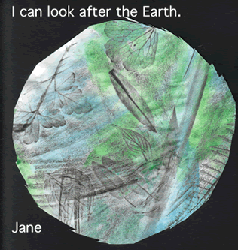
- three or four different leaves
- 11 x 17" copy paper
- black jumbo crayons with the paper taken off
- tape or sticky tak™
- watery green and blue paint
- scissors
- plate
- black construction paper
Directions - The children:
- place the backs of the plants, leaf vein side up, on the table
- place a piece of paper over the leaves and secure the corners with sticky tack or tape to prevent the paper from moving around
- Rub the paper with the side of a thick black crayon (paper taken off).
- have students rub over and over the paper until the leaf shapes show
- paint over the crayon with blue and green watery paint
- use a plate to trace a large circle when the paintings are dry
- cut the "planet Earth" out
- Mount on black construction paper to look like a planet.
- Print a sentence about kindergarten Earth Day if you wish and tape on

